Week: 5 Planning date: 04/10/2021 – 09/10/2021
Period: 12
UNIT 1
LESSON 4: VOCABULARY AND LISTENING: COMPARING PLACES AND THINGS

I. NEW WORDS:

- Dirty (adj) >< clean (adj)
- Unfriendly (adj) >< friendly (adj)
- Old (adj) >< modern (adj)
- Quiet (adj) >< noisy (adj)
- Dangerous (adj) >< safe (adj)
- Ugly (adj) >< pretty (adj)

II. HOMEWORK:
- Learn by heart all the new words.
- Workbook: Exercises 1, 2 page 12.
- Prepare Lesson 2 – Reading.

Week: 5 Planning date: 27/09/2021 – 02/10/2021
Period: 13
UNIT 1
LESSON 5: LANGUAGE FOCUS: COMPARATIVE ADJECTIVES

I. GRAMMAR:
- Short adjectives (1-syllable adjectives)
S₁ + V + Adj-ER+ THAN+ S₂
Ex: Bikes are slower than cars.
- Long adjectives (2 or more syllable adjectives)
S₁ + V + MORE + ADJ + THAN + S₂
Ex: French is more difficult than English.
- Some special cases
good → better
well (healthy) → better
bad → worse
far → farther/further

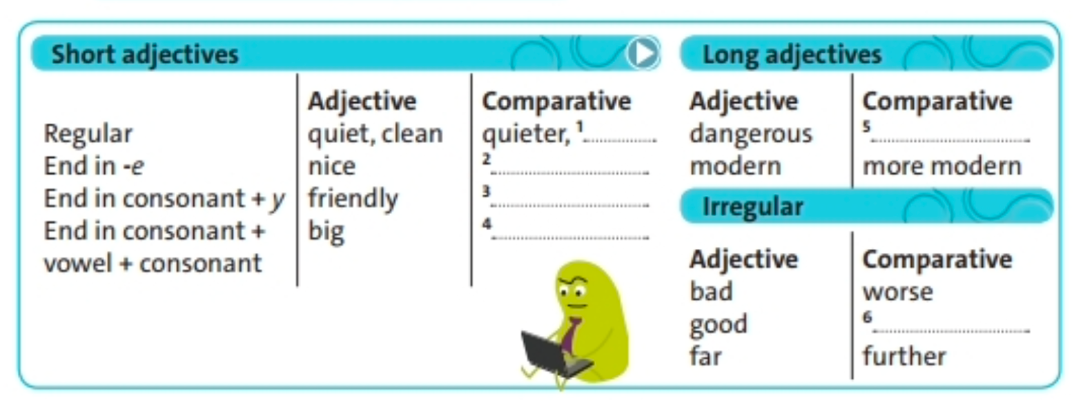

II. HOMEWORK:
- Learn by heart all structures.

Week: 5 Planning date: 27/09/2021 – 02/10/2021
Period: 14
UNIT 1
LESSON 6: SPEAKING: ASKING AND SAYING WHERE PLACES ARE

I. SPEAKING:
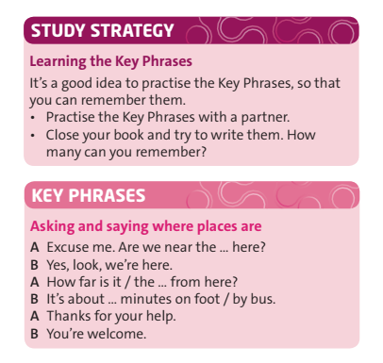

II. HOMEWORK:
- Learn by heart all structures.

